Because we have Custom license we have to report every quarter to the customs the movement of our stock. In short:

Incoming raw material (RM) per coil => in entrepot (bonded)

RM or SRM (Semi raw material) on the machine => in avs (Inward processing)

FG (finished goods), SRM or scrap from the machine => in entrepot (bonded)

FG out as material for free circulation => cleared material

FG out as non European material => with T1 document

An example of the report is attached as excel sheet tab zuivering(22062015). The path to the report is in EMM system: system – system reports – zuivering.

Below is explanation per column what should be in the field and were it is coming from.

Not all fields are known by us were the information is mentioned in EMM system. Maybe you can trace back.

(column A) Type is taken from ???

Type R = Raw Material (Mastercoil)

Type X = Scrap

Type F = Finished Goods

Type S = Semi Raw Materials

(column B) Mothercoil (MC) received in EMS storage. MC in ENTREPOT

MC number is taken from module SHIPMENTS:

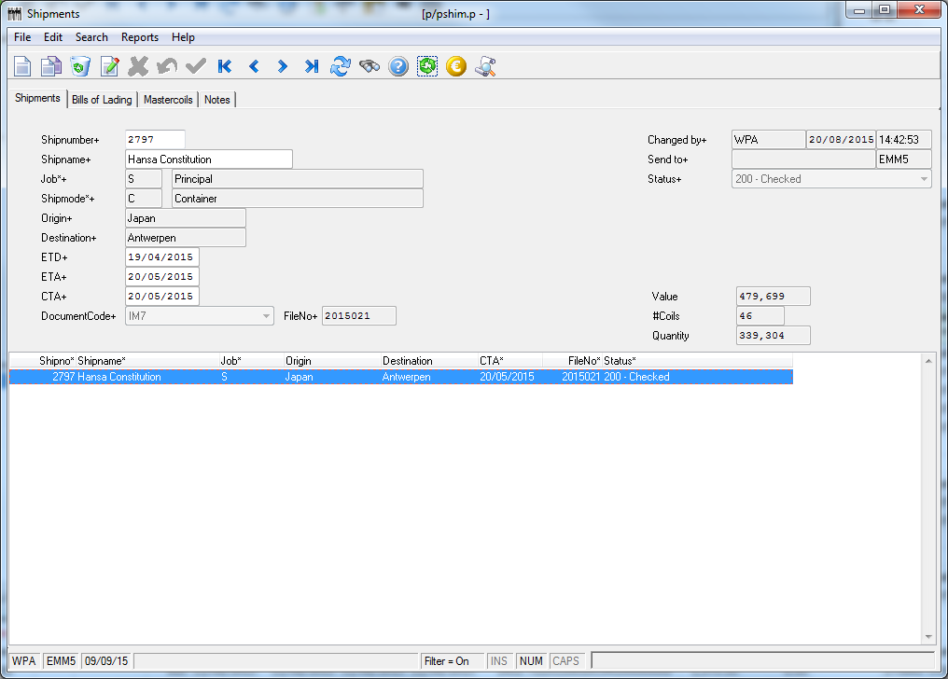

TAB Bills Of Lading

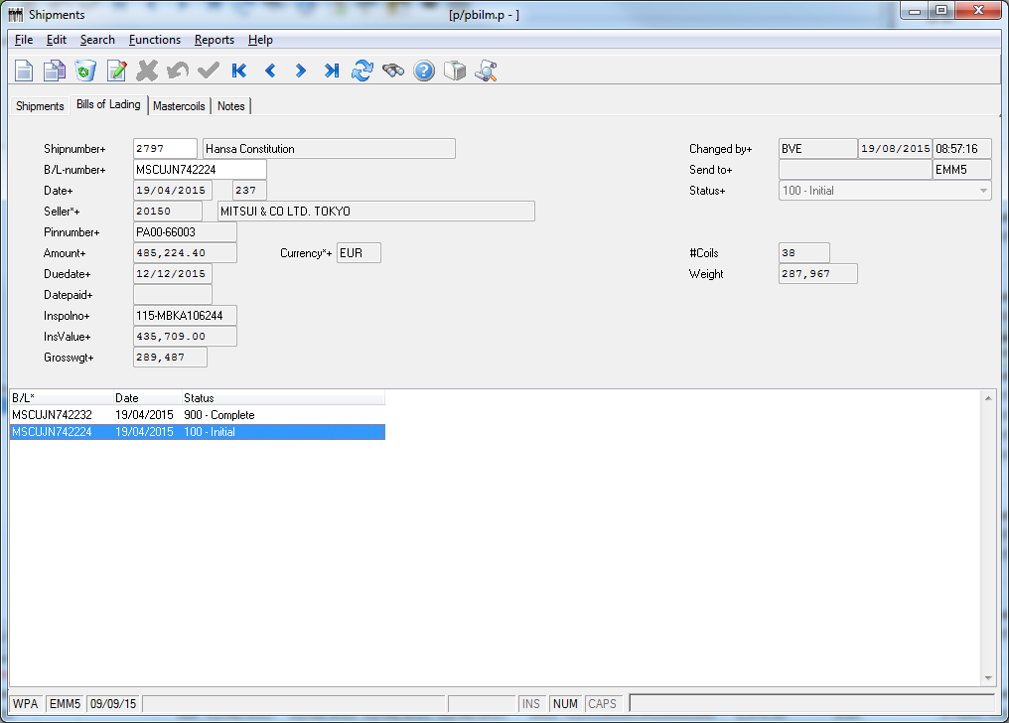

TAB Mastercoils

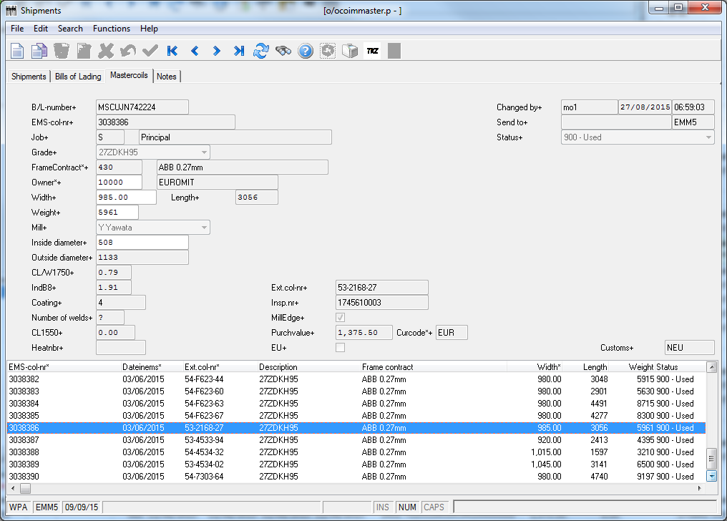

(column C) DocIn/FIAT is taken from ???

When a RM is shipped from the port to EMS a fiat document is made and a number is create.

(column D) DocnrIn is taken from module Call Offs.

Main menu > Incoming > Call Offs

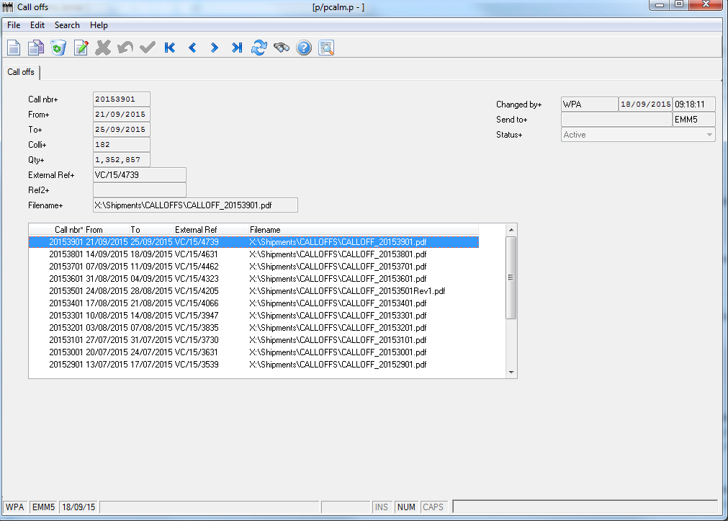

(column E) Status (200/250/900) is taken from module Planning & Production > Coil mgt RM > Column STATUS:

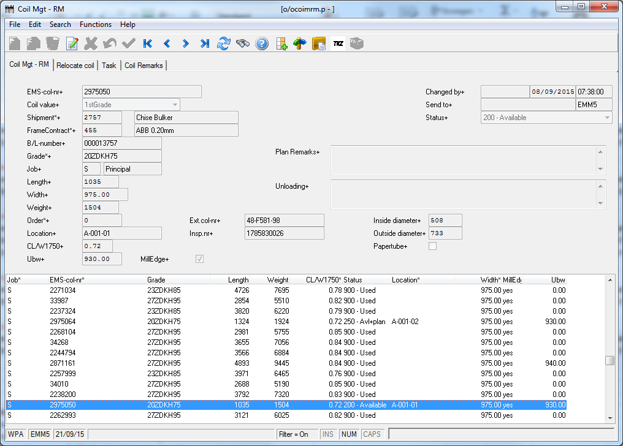

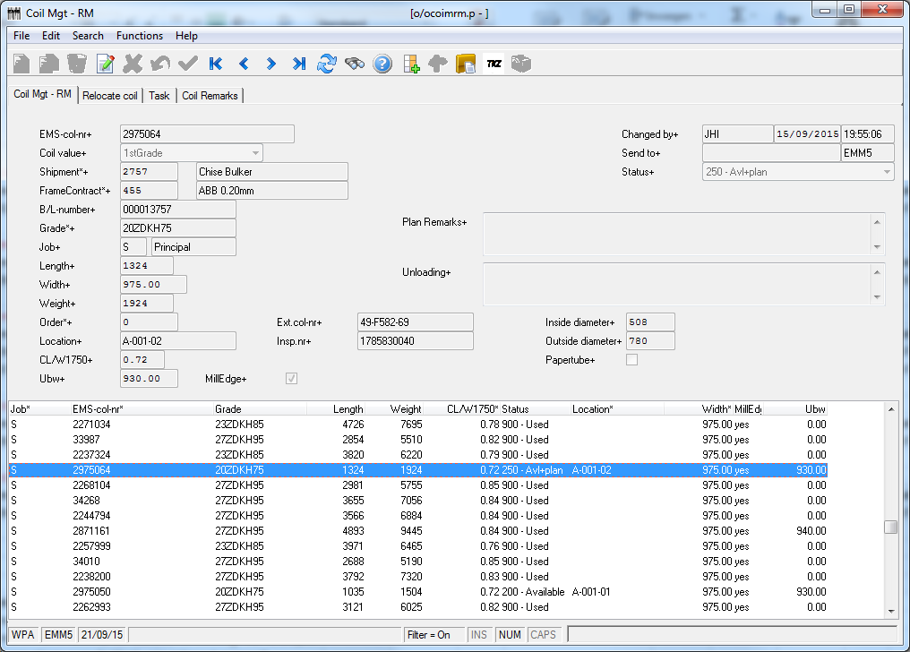

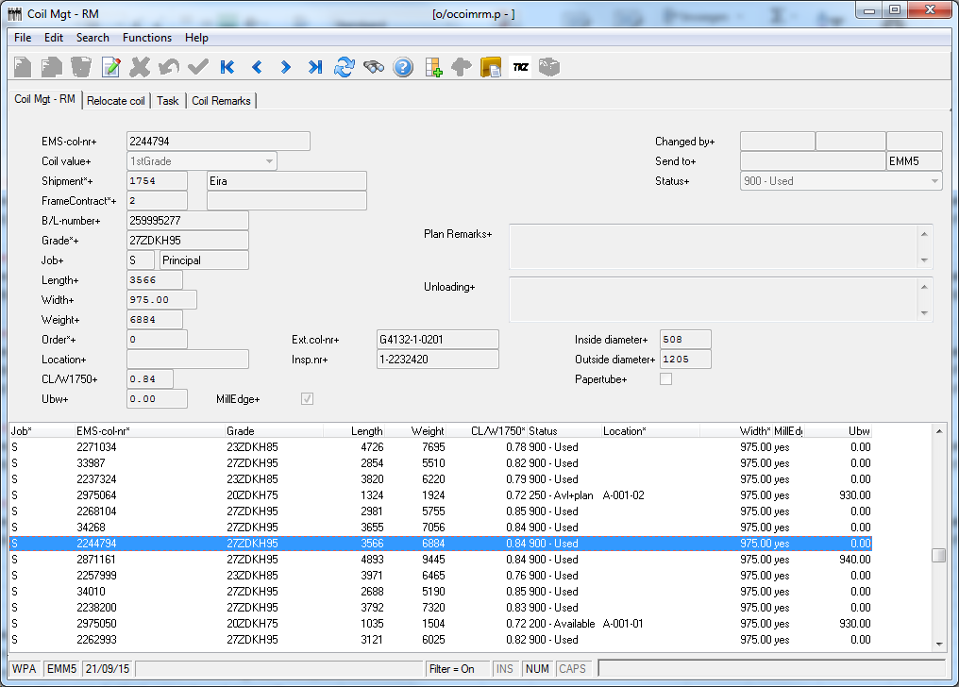

***Or*** is taken from Module Shipments > Tab Mastercoils > column STATUS:

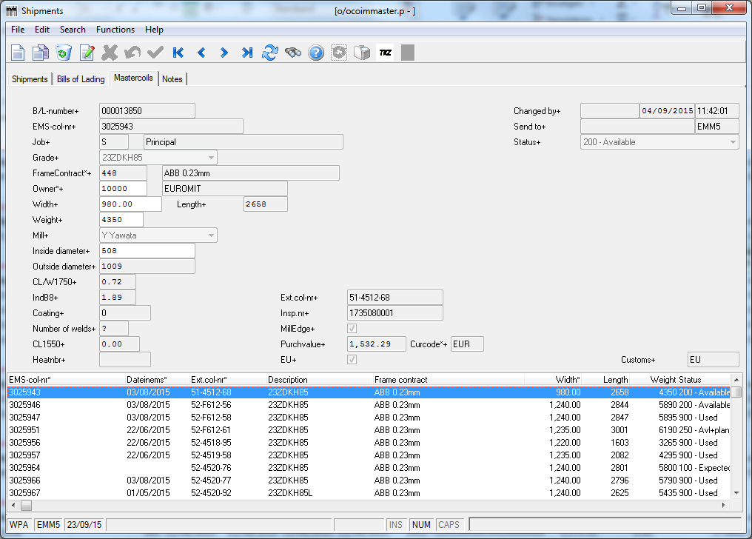

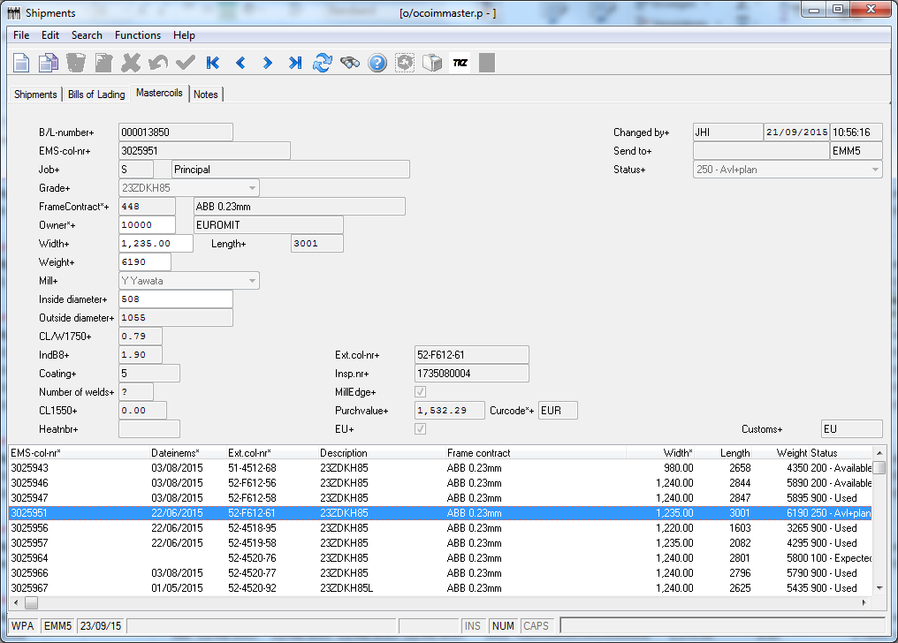

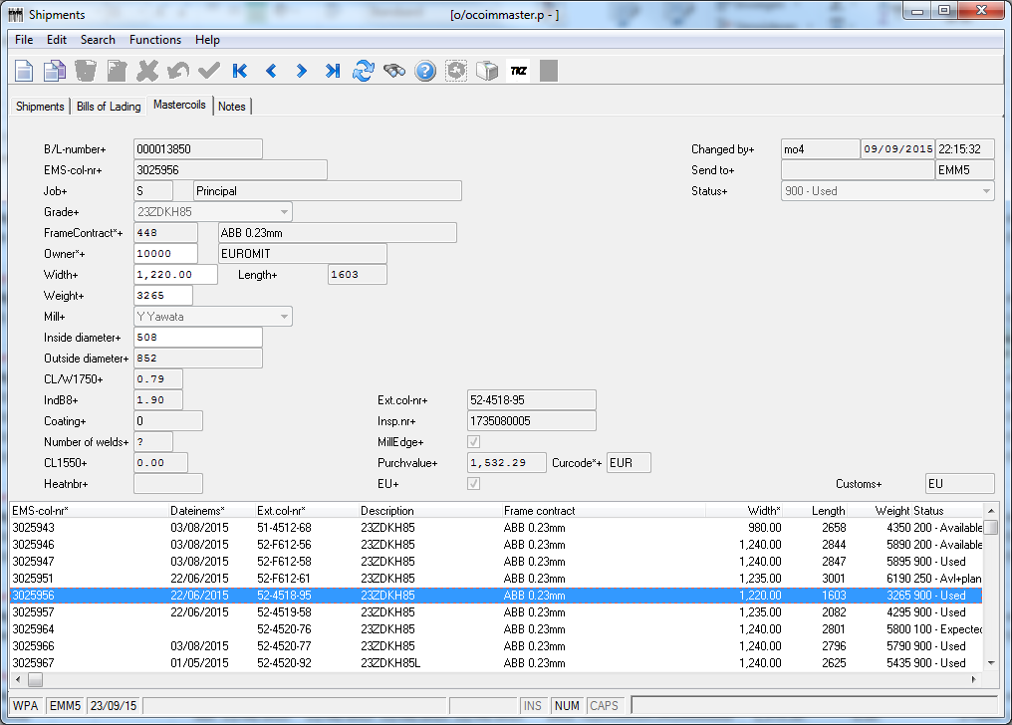

(column F) IN ENTREPOT is taken from module Shipment > TAB Mastercoils > Column DATE IN EMS:

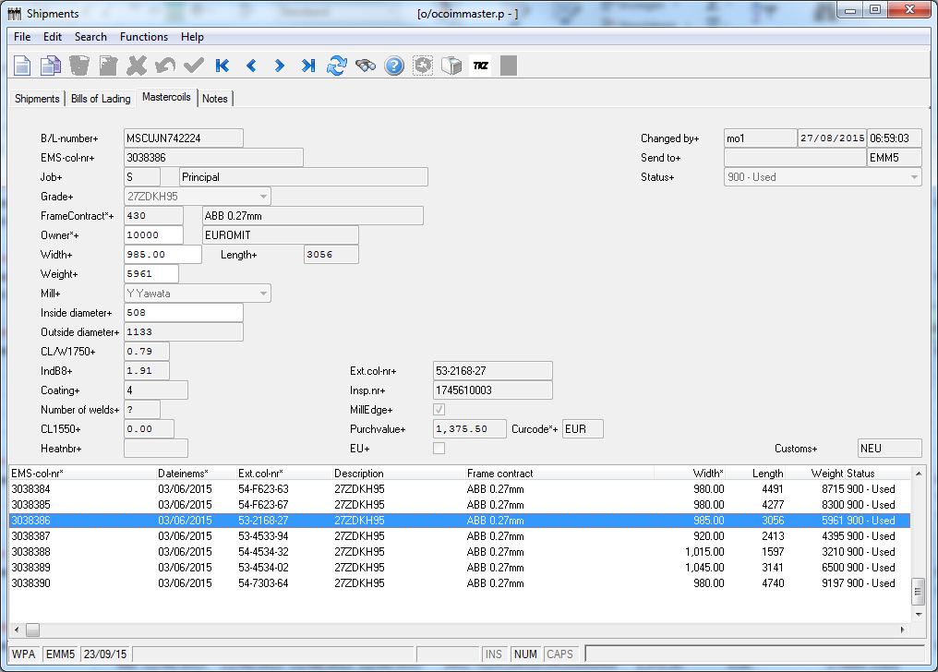

(column G) OUT ENTREPOT is taken from module TRUCK MGT > TAB SET EX-EMS:

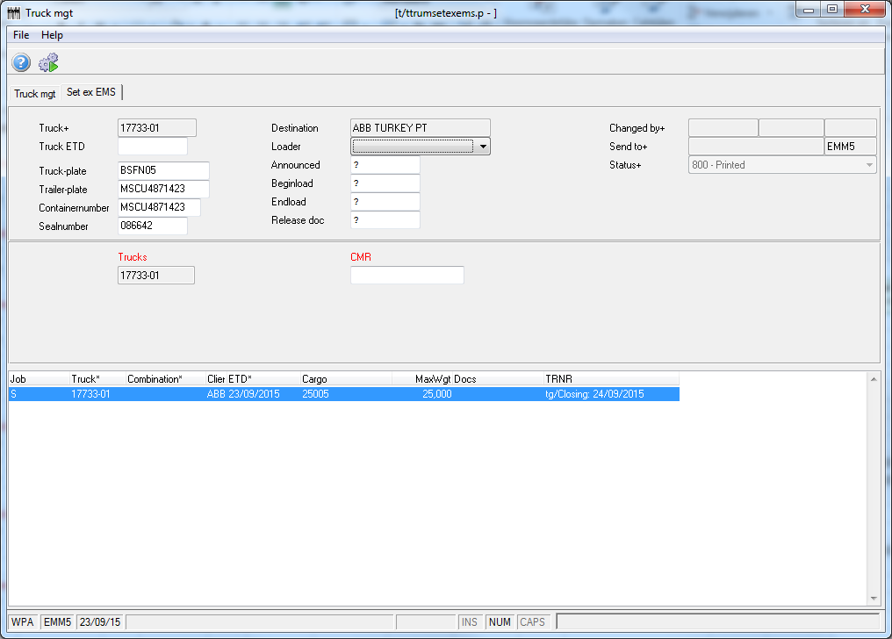

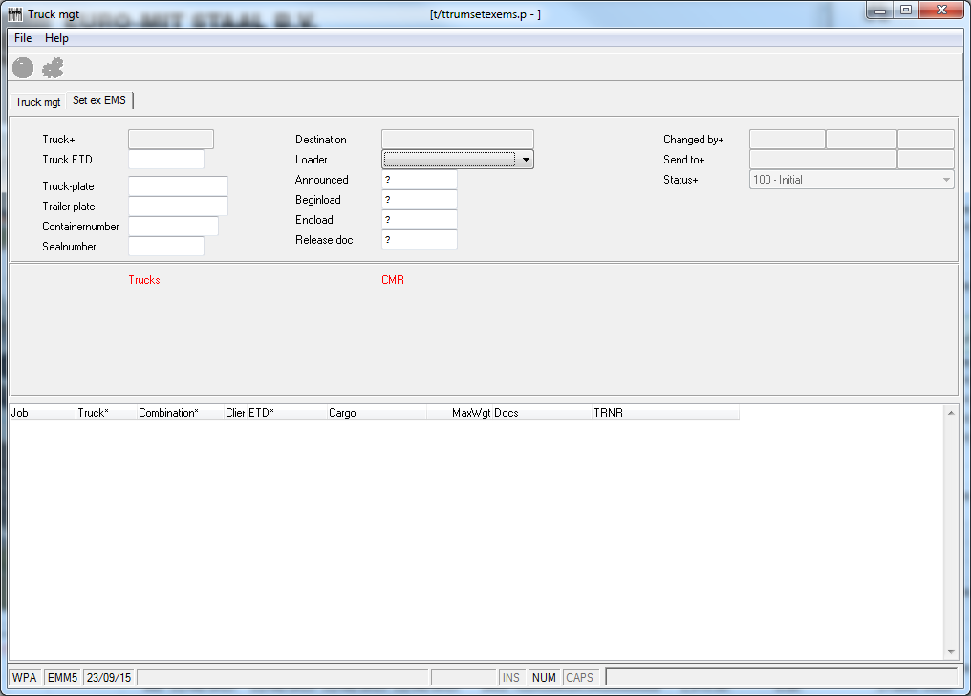

(column H) In AV is taken from Planning & Production > Taskmgt:

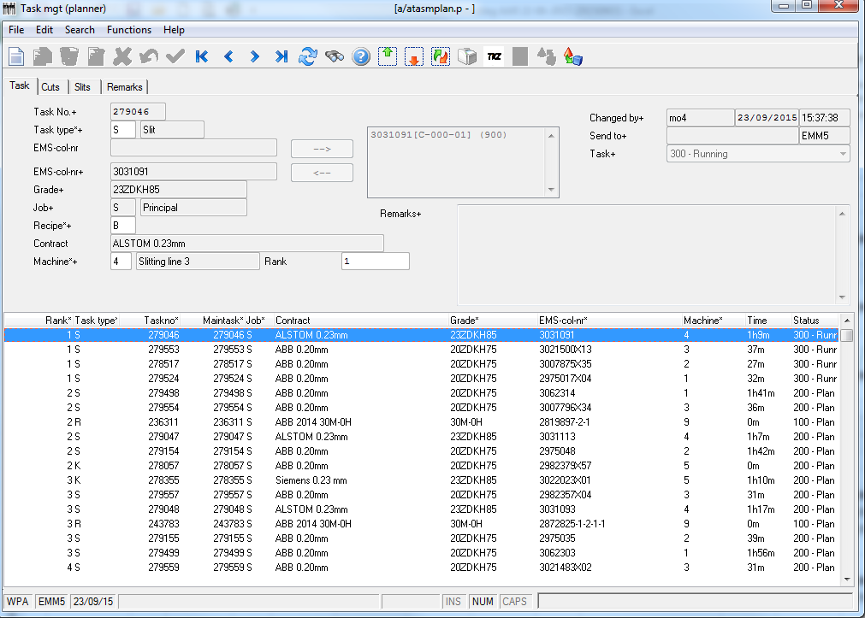

As soon as a task is set RUNNING (status 300) mastercoil will have status IN AV = date of set task running

(column I) OUT AV is taken from Planning & Production > Taskmgt:



As soon as a task is set CONFIRMED (status 900) mastercoil will have status OUT AV = date of set task CONFIRMED (basically IN AV (set running) and OUT AV (confirmed) must have same date)

(column J) WEIGHT is taken from module SHIPMENTS column WEIGHT:



***OR*** is taken from the module Planning & Production > Coil mgt RM column WEIGHT:



(column K) CN CODE is taken from ???

Has to be somewhere in the basetables.

CN codes are:

RM Width > 600mm => 7225110010C04100000000

FG Width > 600mm => 7225110011C04100000000

FG or SRM Width < 600mm => 7226110091C04100000000

Scrap => 7204290010000000000000

(column L) CIF-VALUE is taken from module Shipments > Tab MASTERCOILS:

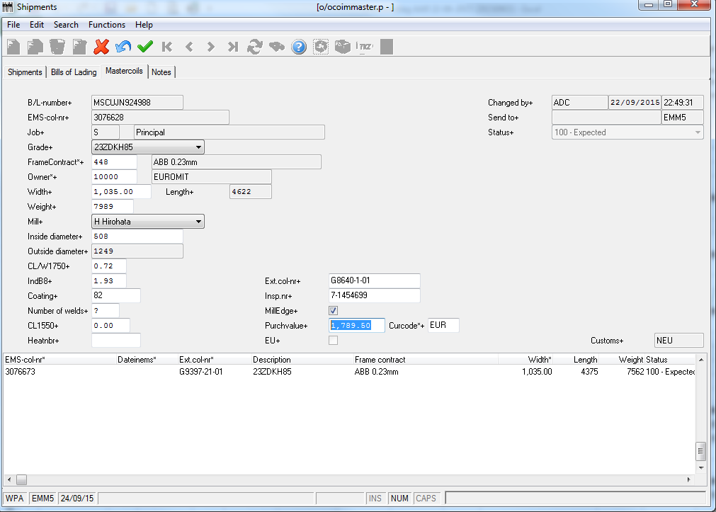

(column M) SALE-VALUE is taken from module ORDERINTAKE > SLITORDERS > TAB ORDERS:

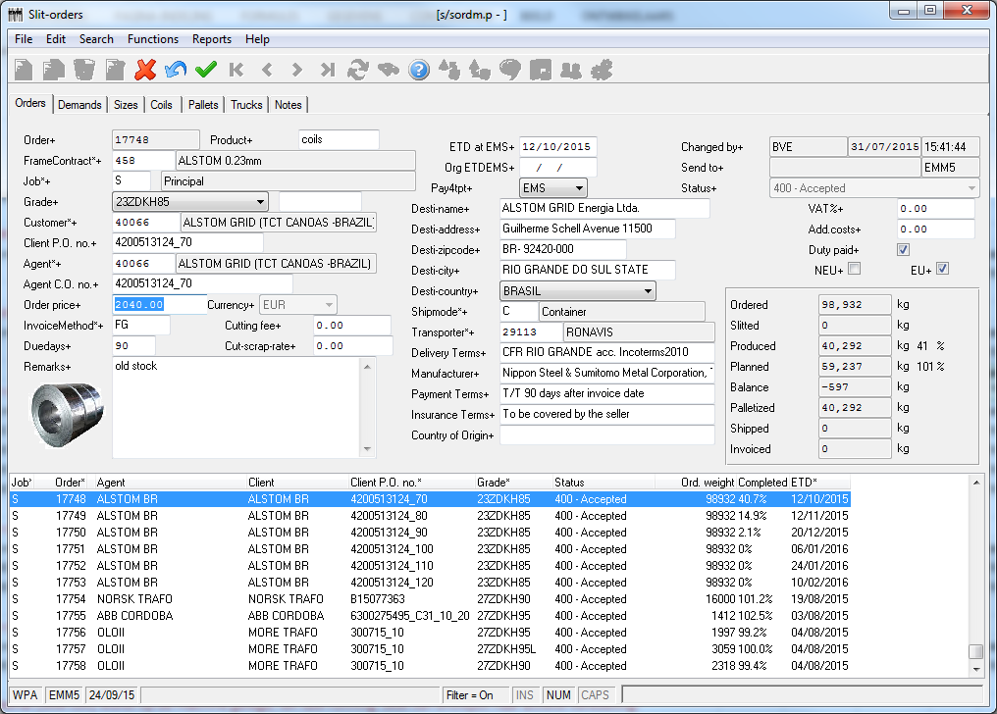

(column N) EX-EMS is taken from module Truck mgt > TAB SET EX-EMS > field TRUCK ETD:

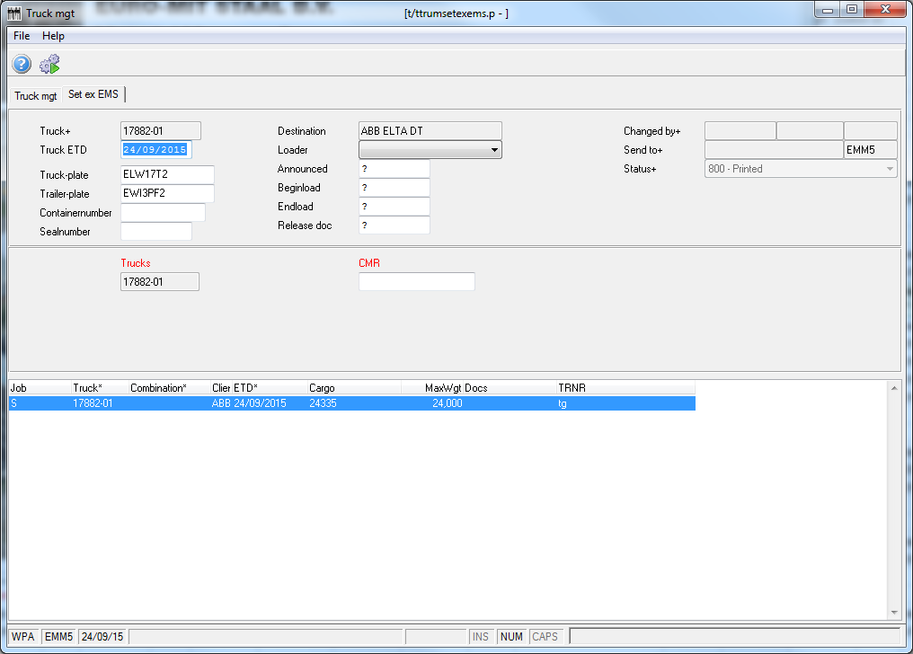



(column O) PIO is taken from module Planning & Production > Task mgt - planner > TAB TASKS (field Task no and/or column Task no)

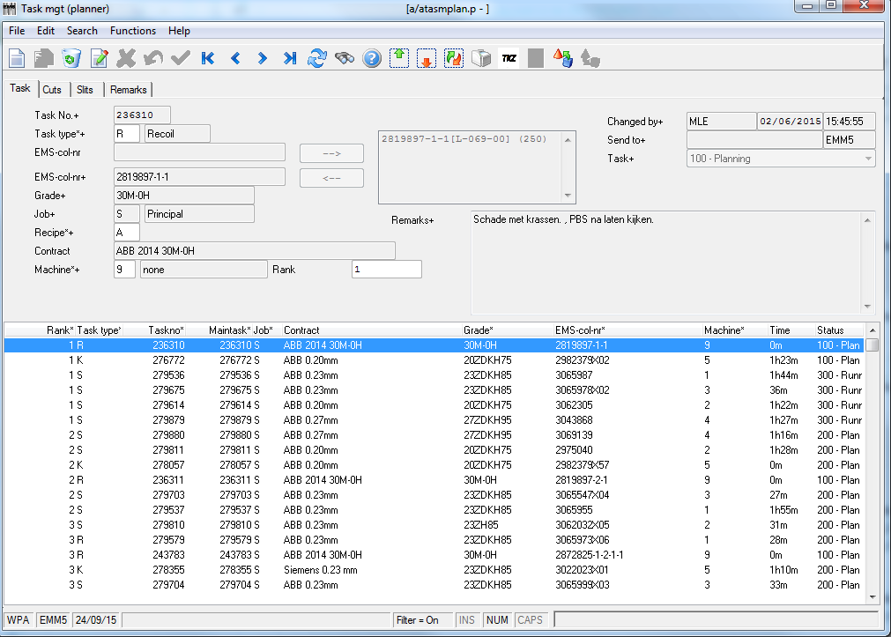

(column P) CUSTOMS is taken from ??

As soon as MC is booked in EMS coil will get status ENTREPOT.

As soon as MC is slitted into smaller coils, MC will get customs status USED and smaller coils will get customs status ENTREPOT

(column Q) DOC OUT is taken from module OrderIntake > Sales orders > TAB orders:

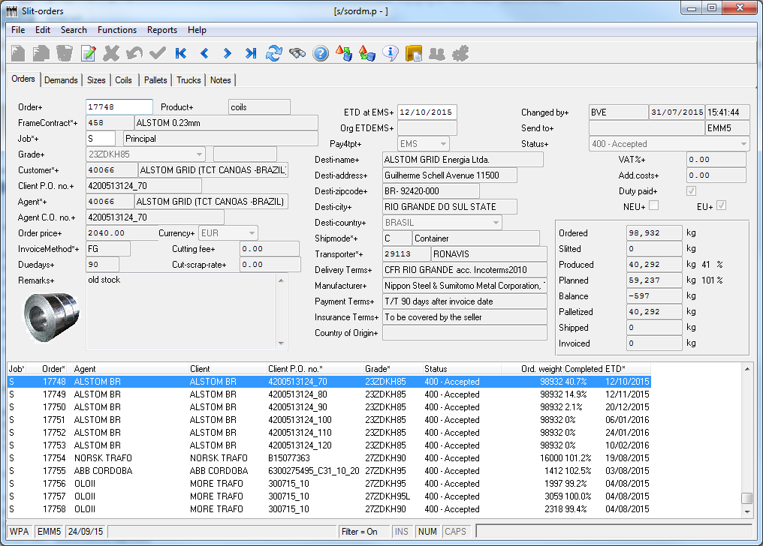

Checkboxes Duty Paid, EU, NEU are leading for mentioning correct info in column Q

Or (column Q) DOC OUT is taken from module Outgoing > Truck mgt > checkbox T1 or IMA

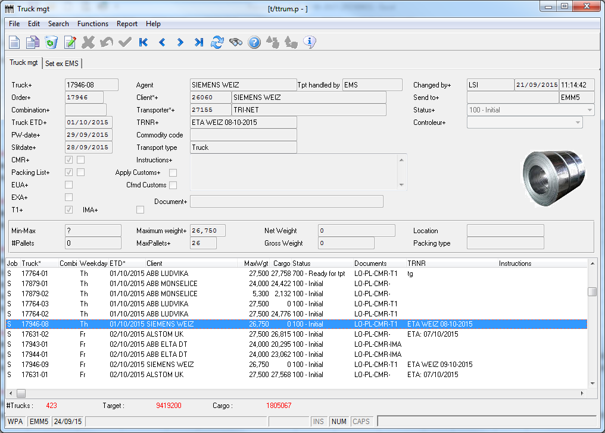

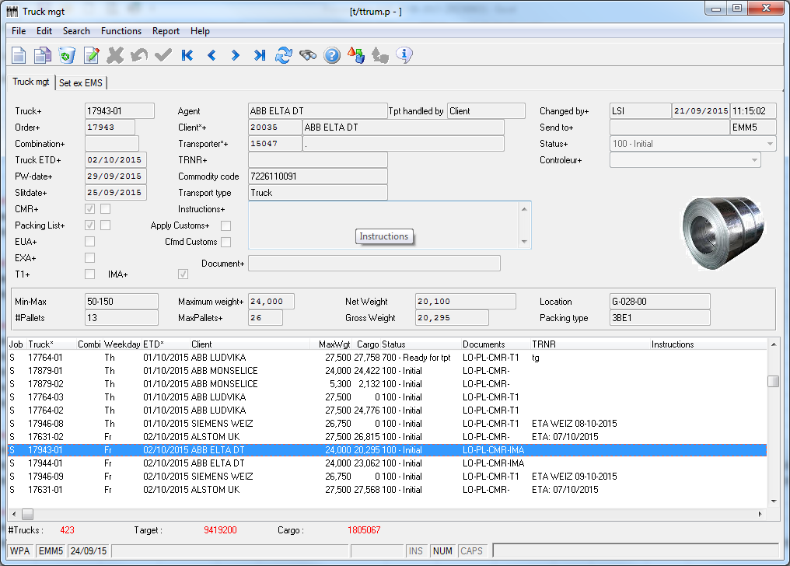

(column R) Docnr Out is taken from module OUTGOING > Truck mgt > Report > Confirm Customs >

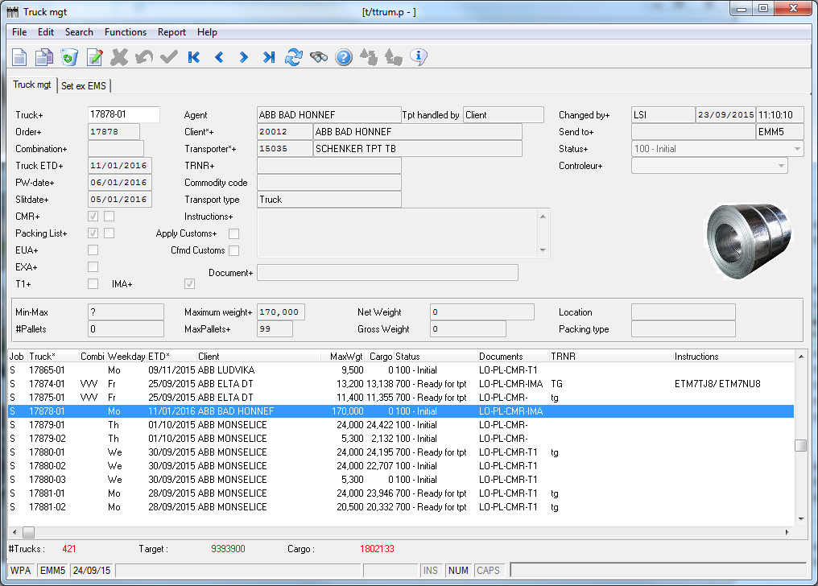

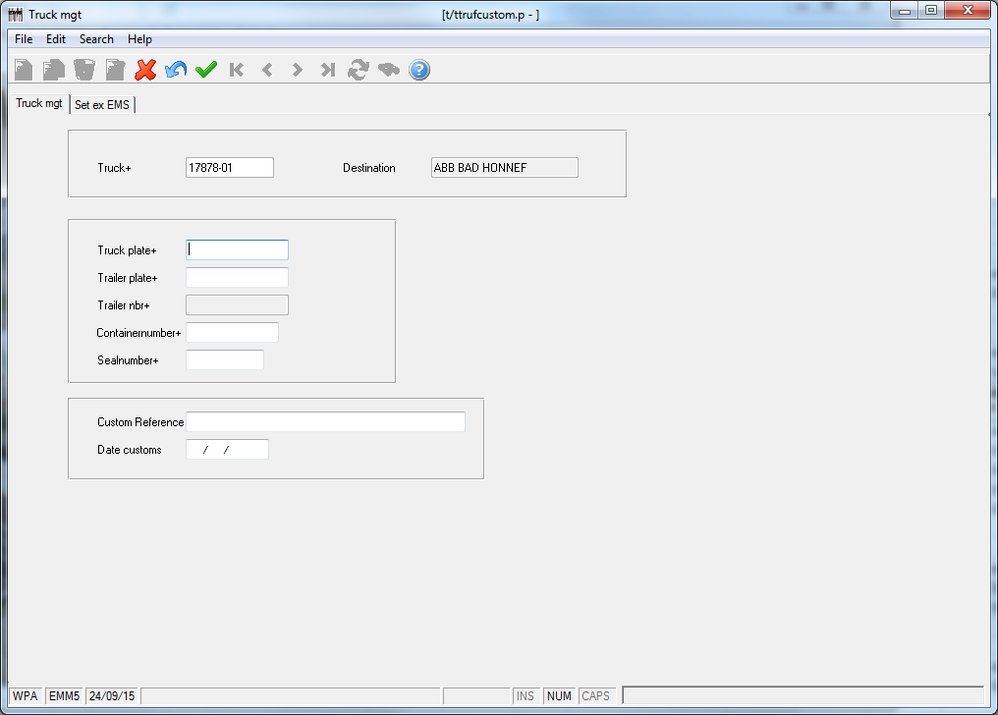

Field CUSTOMS REFERENCE will be filled in with customs doc number.